ASSOCIATION DUES

The next dues payment will be

due in April.

$65 was due at the beginning of October.

If you have not paid yet, please do so immediately to prevent further fees or collection actions.

Mail your payment to PO Box 1764, Lawton, 73502-1764.

FYI There is a $1 service fee for online payments and a $20 fee for returned checks.

**Note from the Secretary**

*We have had occasional comments about the cost of mowing, but I think you’ll agree that we’re paying a reasonable amount when you consider the following:* In addition to mowing, trash and debris is picked up every month, and flowers are planted at the pool for the summer. Mowing is done April-October. We mow **9 acres** (the equivalent of 80 average household yards)!!

[MPHAsecretary@gmail.com](mailto:MPHAsecretary@gmail.com)

**Please join us and help your neighbors.**

We still need Ward Representatives for the following areas:

Ward 2 201-234 and 301-305 NE 46th

Ward 4 4601-4632 NE Dearborn

Ward 5 4604-4610 NE Euclid, 236-244 and 403-419 NE 46th

Ward 14 5001-5114 Haddington Place

**CONTACT INFORMATION**

[MPHA1764@yahoo.com](mailto:MPHA1764@yahoo.com)

MPHA PO Box 1764 Lawton OK 73502-1764

Doug Welch (580-475-1758) President

Rupert Foster (580-357-4690) Vice-President

Debra Welch (580-736-3165) Financial Officer

Randy Barker (580-574-9815) Grounds Chairman

WARD REPRESENTATIVES

**Brooke Fife** (580-357-5269) **Ward 1** (102-116 NE 48th Circle, 4604-26 NE Bell, 4701-15 NE Bell) **Paul McWilliams** (580-583-4779) **Ward 3** (4603-27 NE Columbia, 301-315 NE 48th) **Rupert Foster** (580-357-4690) **Ward 6** (4501-11 NE Euclid, 4501-10 Highlander, 4512-18 Highlander)

**Ashley Lazzerini** (580-458-1076) **Ward 7** (4511-19 Highlander, 4520-38 Highlander, 502-510 NE 48th)

**J.C. Ashmore** (580-248-8034) **Ward 8** (4701-37 NE MacArthur Circle) **Andrew Guglielmo** (904-501-9702) **Ward 9** (4801-4839 NE Winfield Circle) **Randy Barker** (580-574-9815) **Ward 10** (4802-5001 NE Bell, 1-13 NE 48th St., 1-9 NE 48th Place)

**Krystinia Thorpe** (803-318-1728) **Ward 11** (202-210 NE 48th St., 5101-09 NE Bell, 4801-20 NE Columbia)

**Shariol Warner** (580-250-1166) **Ward 12** (5001-5101 NE Dearborn, 101-113 NE 51st)

**Paige McLaughlin** (580-331-9946) **Ward 13** (101-129 NE 52nd)

**Donald Taylor** (580-678-3080) **Ward 15**

(5052-5062 NE Viking Lane, 303-510 NE 51st)

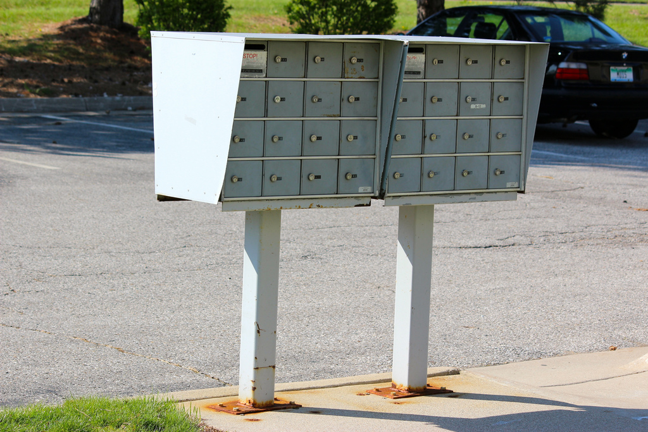 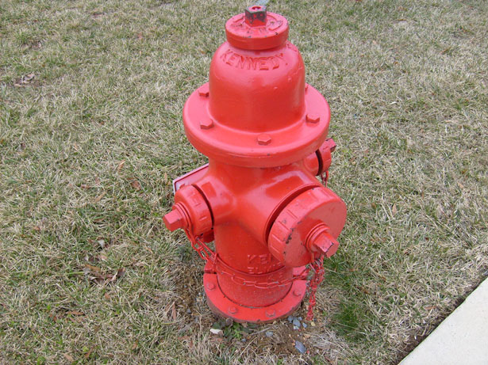

Please be neighborly.

Residents and their guests should not block the mailboxes or the driveways of others. And of course, there is no parking in front of fire hydrants.

PRESORTED STD U.S. POSTAGE PAID LAWTON, OK 73501 PERMIT NO. 105

MACARTHUR PARK HOMEOWNERS ASSOCIATION P.O. BOX 1764 LAWTON, OK 73502

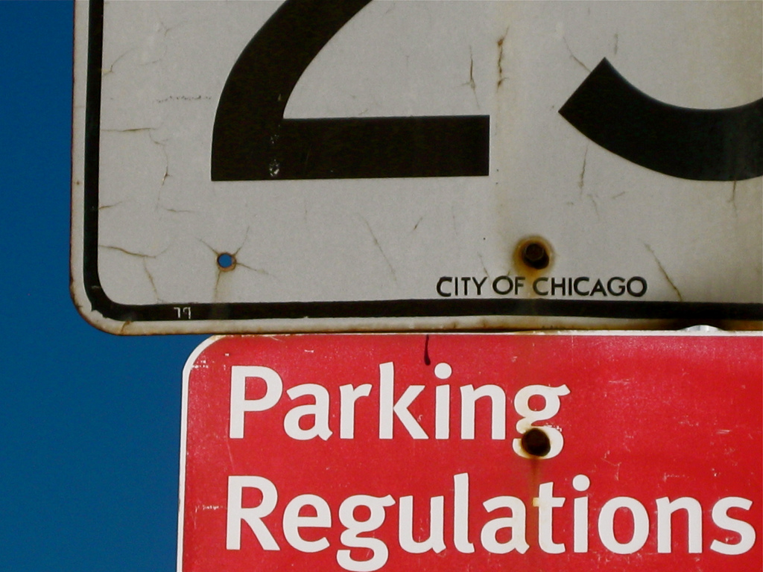

**According to city code, all vehicles must be parked:**

* **45 feet back from any intersection**
* **15 feet away from any fire hydrant**
* **Within 12 inches of the curb**
* **Facing the flow of traffic**

**These regulations apply to residential as well as commercial areas.**

BOARD MEETING DATES

Meetings are held the first Monday of each month at 7 PM in the MacArthur Middle School commons area.

April 2nd

May 7th

We will be discussing plans and costs for the pool to get ready for the upcoming swimming season. We’d like to get your input. We will be needing *lifeguards.*

All residents are welcome, whether renters or homeowners.

MPHA Neighborhood GARAGE SALE **June 1st and 2nd**

Once again, we will be advertising a neighborhood-wide garage sale. The association places the ad, but individual households will have to get their own permits and signs from the city at a cost of $5.00.

We are also usually able to arrange for Goodwill or the Salvation Army to be in the MMS parking lot at a specified time to pick up anything you don’t sell.



[This Photo](http://silvercreektribune.com/2013/04/15/silvercreek-community-association-garage-sale-reminder/) by Unknown Author is licensed under [CC BY-NC-ND](https://creativecommons.org/licenses/by-nc-nd/3.0/)